Linear Rails
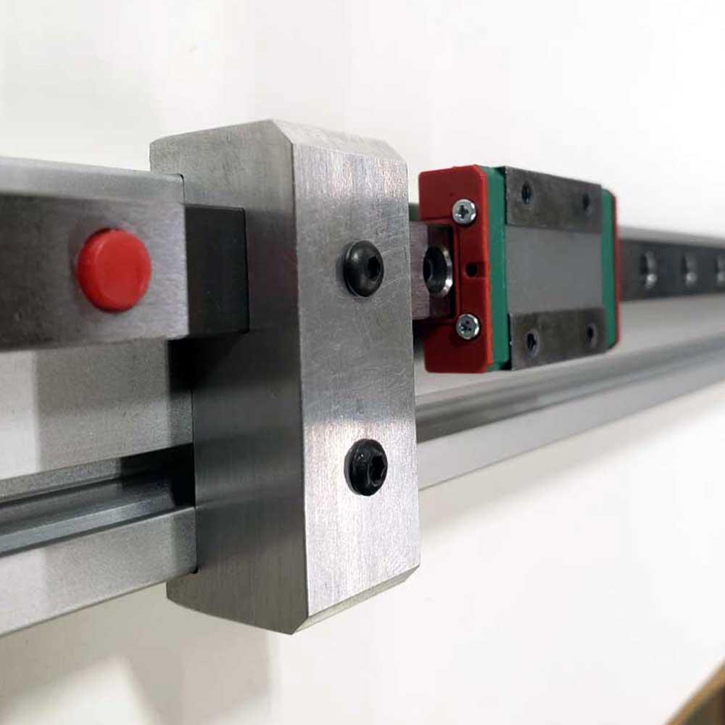

X-Axis Rails

Zyltech MGN12H-TYPE - Linear Rail with Single Carriage Block
2pcs x 700mm Long
Estimated Price
$61.95 each

Y-Axis Rail
Zyltech MGN12 H-TYPE - Linear Rail with Single Carriage Block
1pc x 400mm Long (or 450mm Long)
Estimated Price Each
$29.95

Z-Axis Rails
Zyltech MGN12 H-TYPE - Linear Rail with Double Carriage Block
4pcs x 500mm Long
Estimated Price Each
$44.95

Linear Rails | Price $ Each | Discription | Source
450mm or 400mm Long w Y axis (1pc) | $ 61.95 | MGN12H 20mm x 20mm Hole Pattern | ZYLtech
700mm Long X Axis (2pc) | $ 29.95 | MGN12H 20mm x 20mm Hole Pattern | ZYLtech
500mm Long Z Axis (4pc) | $ 44.95 | MGN12H 20mm x 20mm Hole Pattern | ZYLtech
Total | $ 301.65
Total w/shipping + Tax | $361.17

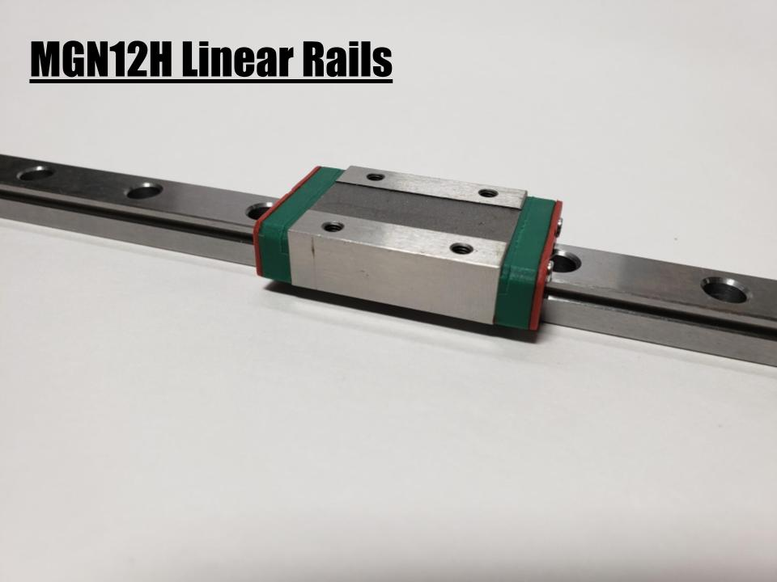

WorkHorse Printer Linear Rail Kit

MGN12H Linear Rails
2 x 700mm Long with Single Carriage Block
1 x 400mm Long with Single Carriage Block
4 x 500mm Long with Two Carriage Blocks
M3 mounting hole spacing 20x20mm

Lubricating Linear Rails
Here’s a product designed by Michael Hathaway for linear rails.
Note: Don’t Spill it or use it too much. It will never wash off and forever be lubricated.

TinkSeal

TinkSeal on Ebay

YAMAHA - ULTRAMATIC GREASE Substitute 4oz

TinkSeal™ is Not a grease and that is why it works so well for this application. TinkSeal is made from both liquid and dry lubricants combined at an elevated temperature under pressure. It's a carrier system to get lubrication to the area where it is needed. It's not just a substitute for Yamaha Ultramatic grease, it's a superior product. TinkSeal™ outperforms Yamaha's Ultramatic grease in every area.

** Can be directly used on all sliding CVT weights, both Yamaha and aftermarket weights

Lower friction resistance than Yamaha brand Ultramatic Grease

Can be used on all primary and secondary sliding surfaces (Yamaha brand requires the purchase of multiple grease products for their solution)

Increases the interval times between sheave maintenance and cleaning

Ultra High Pressure Lubricating Grease with Nano particle transfer

Yamaha recommends (90g) 3.1 ounces to be used inside the primary sheave

**Automotive greases are too heavy viscosity for normal sheave operation. Tinkseal™ Ultramatic has been modified to work directly in Yamaha sheaves

Related Content
WorkHorse BOM

Also See

WorkHorse 3D Printer
SolidCore CoreXY
MGN12 Type-H Linear Rail
Linear Rails
Igus Lead Screw
Linear Rails
WorkHorse Frame
WorkHorse Motors
WorkHorse Printer: Users Guide
Duet Wifi Setup
Duet 2 vs Duet 3
WorkHorse 3D Printer
Recommended Print Settings
3D Distributed

Firmware Files
config.g
Homeall.g
homex.g
Homey.g
Homez.g

Duet 3 Mainboard Setup
Duet3D YAT Commands
Reverse Motor Direction

Duet Wifi
Duet Wifi Setup

